Ideation Phase
Idea Prioritization Template
Date | 31 OCTOBER 2025
Team ID | NM2025TMID04230
Project Name | Education Organisation Using ServiceNow
Maximum Marks | 2 Marks

Empathy Map
Alex SAYS they are frustrated by having to log in to three different portals just to manage their school life. They frequently voice a desire for a central place to track the status of all their support requests, and they find the existing "Knowledge Base" to be too full of technical jargon. Internally, Alex THINKS the new ServiceNow system must be an improvement over the "old clunky portal," and they worry about missing critical deadlines because of disorganized information. A major concern is the security of their data. In their environment, Alex SEES a confusing array of disparate departmental websites on their phone screen, and they observe long lines at administrative offices. They are constantly exposed to outdated forms and urgent, system-generated alert banners. Alex HEARS their peers complaining about slow IT and inconsistent support, and they hear faculty and staff blame system slowness. This is all contrasted by media exposure to modern consumer apps and other universities' seamless digital transformation efforts.
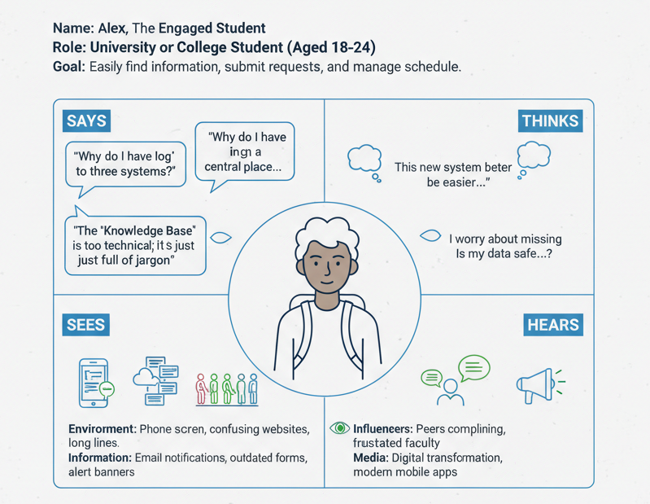
Pains, Gains, and Needs
The primary PAINS Alex experiences are the fragmented experience across multiple legacy systems, the slow resolution times for critical requests, and the overwhelming amount of unorganized information. To succeed, Alex requires specific GAINS, including a single, intuitive portal on the ServiceNow platform, real-time transparency into the status of all submitted requests, and easy self-service via a smart knowledge base. Fundamentally, Alex NEEDS a mobile-friendly interface for on-the-go access and automated reminders for deadlines.

